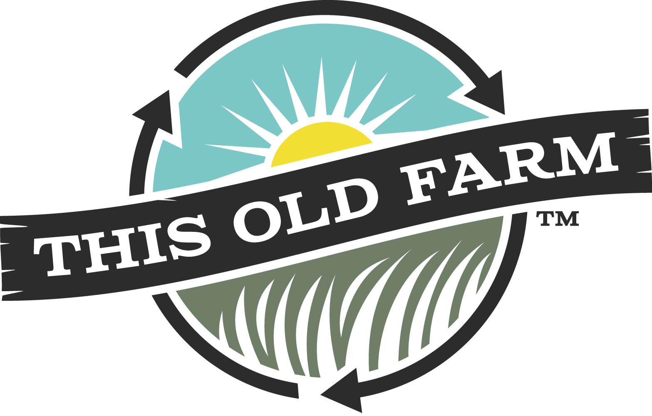
 | 9572 W Co Rd 650 S  Colfax, IN 46035  www.thisoldfarm.com  (765) 324-2161 | LIVESTOCK DROP OFF SHEET | Effective: 08/24/2023  Last Revised: 04/26/24  Revision # 25  FORM-OFF-24

Farmer Name:  Farm Name to use on Meat Package Labels:  Phone Number: ( ) -  Email:  Address |  | To allow us to best take care of your customers, all cut instructions are due by the day of slaughter. Cut instructions may be completed by visiting thisoldfarm.com and submitting the electronic form.**See additional info on back/page 2.

Private Label Use  ($66.50 per order one time setup fee. All label claims will be $19.97 per order.) If you have a label claim not listed but approved, please advise staff.  Private Label? Yes | No  Use Private label on customer orders? Yes | No | Label Claim for Private/Retail Use Only  (Up-to-date Organic Certification/Label Claim Producer Application must be on file prior to drop-off for all label claims. 10% increase per order for organic processing)  Certified Organic Farm? Yes | No  100% Grass Fed Beef? Yes | No  Pasture Raised Hogs? Yes | No

Drop-off Date: |  | Recorded Drop Off Time*: |  | Scheduled Slaughter Date:

Number of Animals: |  | Do you want us to send live and hanging weights: Call | Email (circle one)

CATTLE: Dairy: Yes | No Age:  Breed:  **The USDA requires us to remove any part of the spinal column of a beef older than 30 months. Occasionally beef over 24 months show signs of being over 30. To avoid USDA required changes to customer cutting instructions, please provide birth records at drop off on ALL beef between 24 and 30 months. A $36.30 per beef fee will be applied to all beef deemed “plus 30” **  Grade & Yield ($19.97/animal): Yes | No | Offals ($19.97/animal):  Liver  Heart None  Tongue  Kidney  Head ($33.28)  Hide ($60.50)  Horns ($36)  (circle each to save) | HOG/LAMB/GOAT:  Breed:  **We recommend birth records for all lambs. Without sufficient birth records, lambs will occasionally be deemed as mutton when under 14 months due to premature eruption of teeth** | Offals ($7.99/animal):  Liver  Heart None  Kidney  Caul Fat  Head ($33.28)  Hide ($60.50)  Horns ($36)  (circle each to save)
We must know at the time of drop off if your customers want offals from their assigned animal.
Designated Pen #: ______________ Organic livestock have been placed in a pen by itself ________________
Ear Tag #/Pen Marks used for assigning animals ___________________________________________________________
Slaughter Notes:
*Any livestock arriving before or after the stated drop off times are subject to a $33.28 per animal fee.* Cancellations and/or no show animals are subject to $50 per animal fee. All livestock will be federally inspected. ($19.97 per order for inspections and to maintain facilities) Farmers are responsible for ALL meat left after 30 days. This Old Farm is not responsible for livestock housed prior to slaughter. We recommend same day drop off (especially during cold weather months as our barn is not heated/bedded). Lamb/Goat: $60.50 shear charge may apply for hair sheep, long wool, etc.
Please review front and back and sign below if the information is accurate and complete.
DROP OFF SIGNATURE
We have provided space on the back of this form to assign animals to customers. This information is required even if the meat is coming back to the farmer. Change order fees may apply if information is not complete at drop off. Help us take good care of you and your customers!

Check-in Initials_______

* Please Note: New CI options available. Please Send Your Customers to our Website www.thisoldfarm.com *
All orders will remain in the farmer’s name unless a complete name and phone number is provided below. If the farmer is selected to be invoiced and to pick up the orders, the farmer will be responsible for all orders.
Please know that we use this section to determine who your customers are and which cutting instructions to use when processing your animal. It must be accurate to ensure the best customer service possible.
Customer’s  First & Last Name  If there is more than one order per name, we will use a letter designation (i.e. Smith A, Smith B, Smith C). | Customer’s Phone # | Whole, ½, or ¼ | Which Animal?*  Specify by size or tag number | Personal  or Retail use  (P or R) | OFFALS  Requested  (See Above)  L H T K | Office Use Only  CI Complete
Farmer | Customer (circle one) to be invoiced and to pickup
*If you are specific on which customer gets what animal, please enter the animal information (EX: Ear Tag number, largest, smallest - Etc.) in the “Which Animal?” column. This cannot be listed by breed or color.
**Customers who do not submit cut instructions prior to day of slaughter will be issued our Butchers Basic for beef, People's Choice for pork and Standard butcher cuts for lamb. Cut instructions received after 6:00 a.m. the day of slaughter may be subject to a change order fee.
Office staff are available Monday through Friday 9:00 am - 5:00pm for meat pickup and assistance. Livestock drop off is available the day before your appointment between 3:30-4:00 PM and the day of your appointment 6:00-6:30 AM (no early drop off on Sunday or holidays). Emergency appointments, farm, and trailer slaughter arrangements can be made if needed. Any non-standard process should be notified at appointment scheduling (i.e. horned cattle, injuries, etc.). Emergency, farm, trailer, and non-standard slaughter processes, including cleaning of dirty animals, are subject to additional fees and will be assessed on order invoice(s).
Office Use Only: Early/Late Drop Off: __ Emergency Slaughter: __ Cancellation Fee Qty: ___
Farmer Rep: ____ Other notes: ________________________________________________________

